**USER MANUAL**

**SHOPPING CART**



Submitted by:

BALINAG, John Rey

CACHO, Yz

GADDI, Julina May

MARZAN, Mark Kenneth

OÑATE, Prins Frederick

Submitted to:

Ms. Ria Andrea F. Nana

Table of Contents

**Introduction 1**

**Adding New Contents in the Database1**

Step 1 2

Step 2 2

Step 3 3

Step 4 4

Step 5 5

Step 6 5

Step 7 5

Step 8 6

# 

## Introduction

# This is our shopping cart website that enables every user to visit our site, to buy products with the use of PayPal and by simply browsing the items. It’s just a typical online shopping cart website, similar functionality with others but it is only a simpler version of them.

The user manual provided below will help you out on how we created or on how you can add a particular item that you want. You just need to follow these basic steps.

## Adding New Contents in the Database

In adding the contents in the database using MySQL Workbench and XAMPP, you just need to follow these simple steps below:

**Step 1:** Import the latest version of the database. In this case, we will be using version 1.9 and then click on the ‘Import’ button by creating a new database named ‘game’.

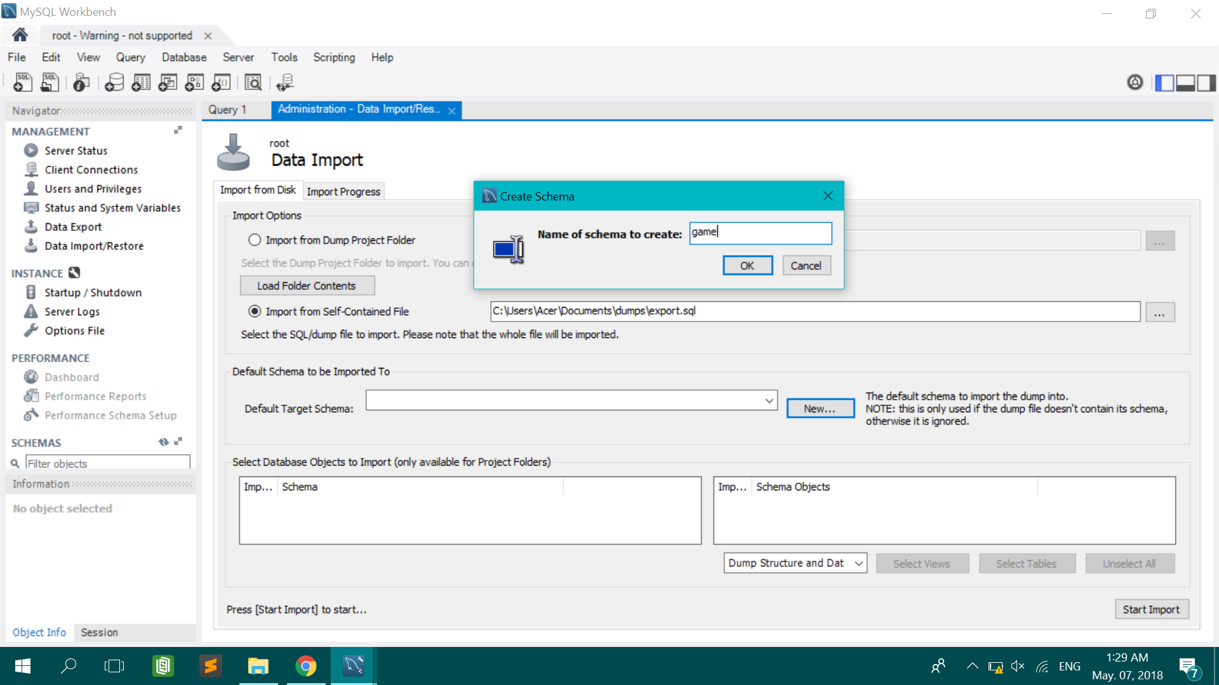

1 | Page

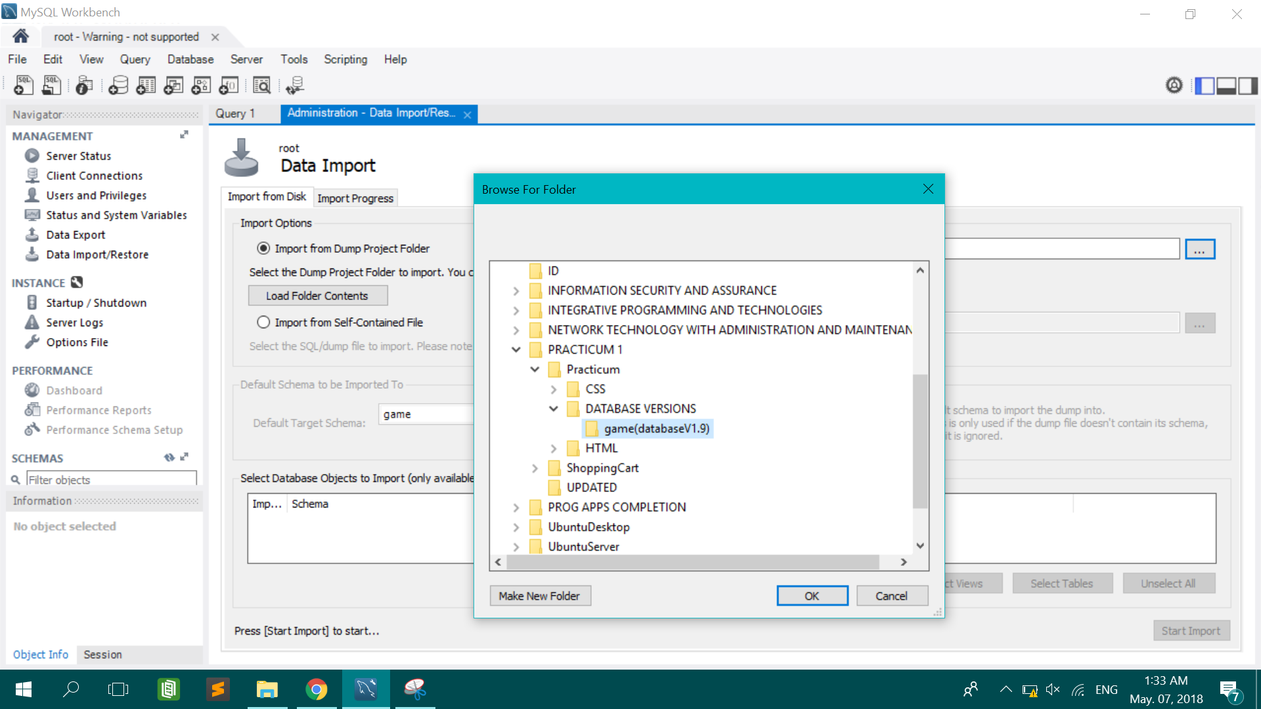

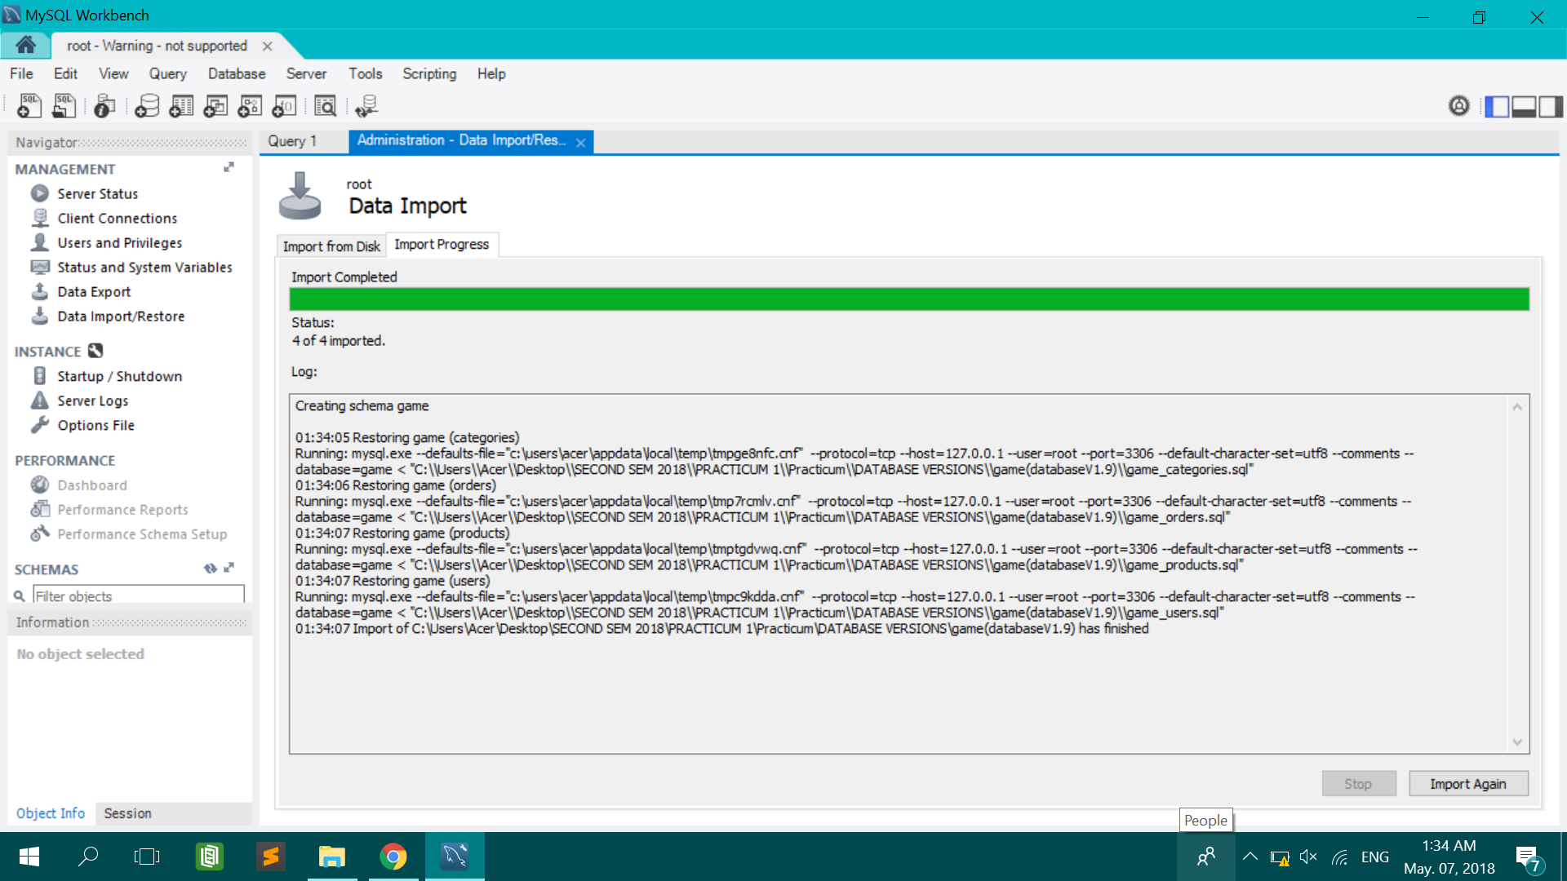

**Step 2:** After importing the database, you need to activate the schema you want by typing this command and the press the shortcut key ‘Ctrl + Enter’.

Command: ***use game;***

2 | Page

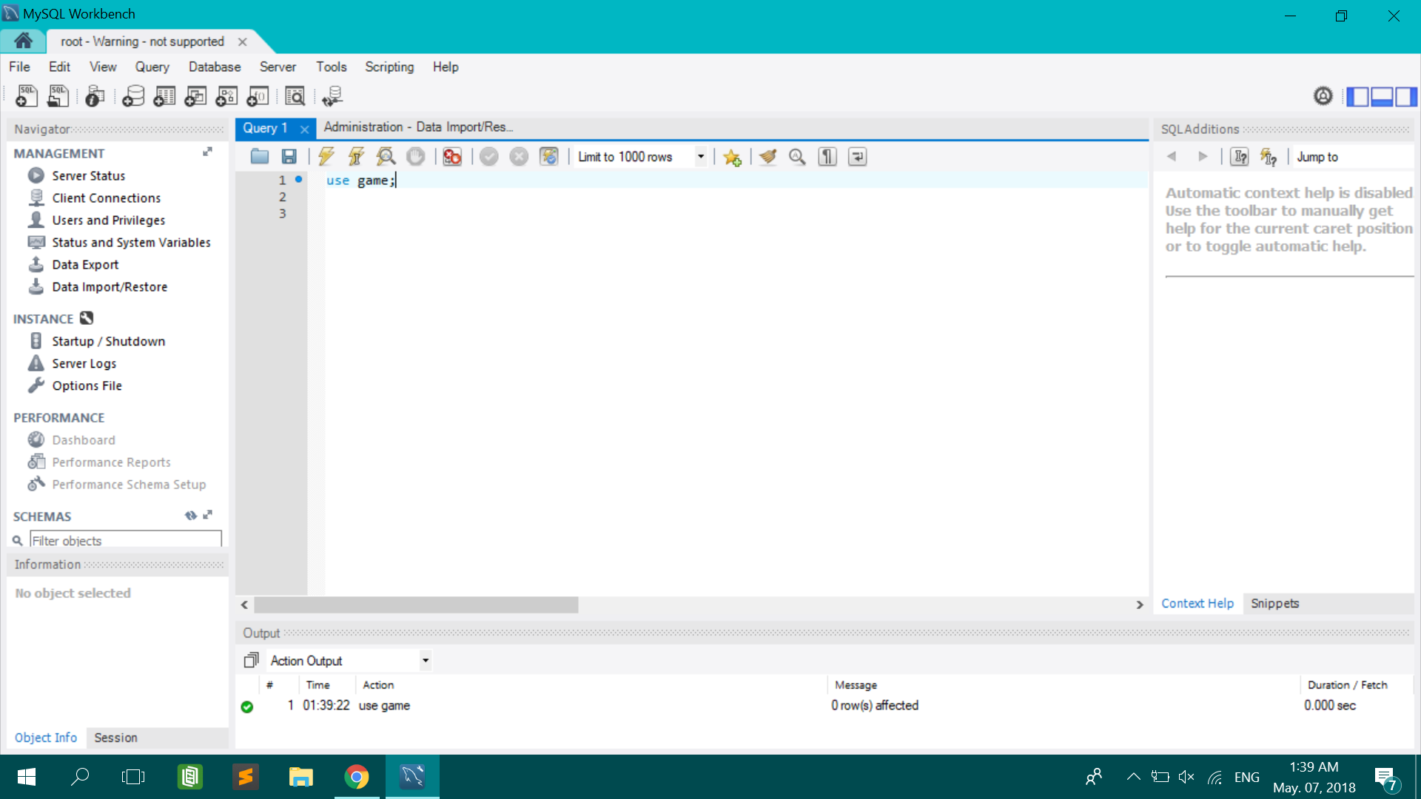

**Step 3:** After activating the schema, you now type this command in order for you to see the following items.

Command: ***select * from products;***

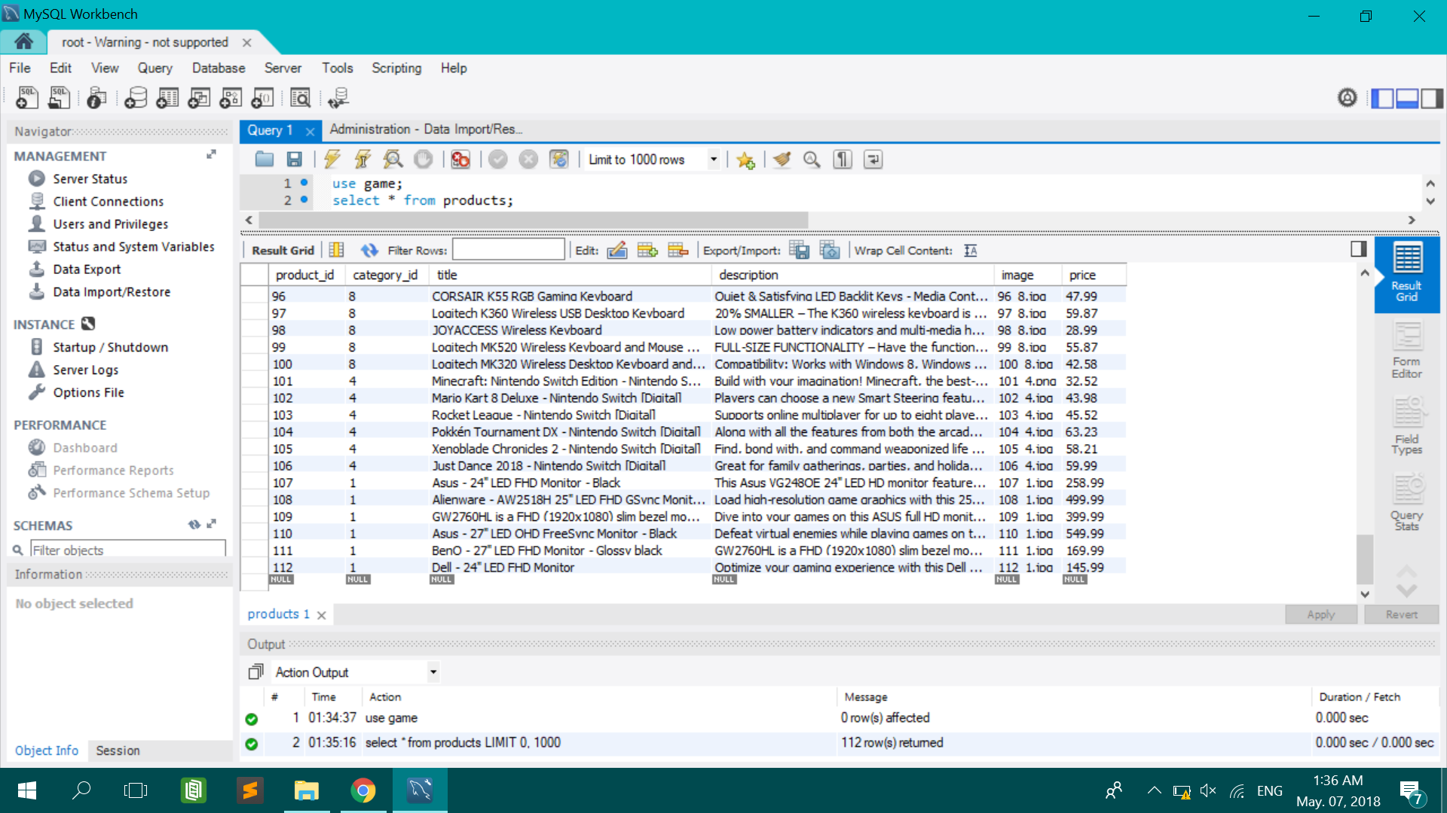

3 | Page

**Step 4:** Now, you can put additional contents. For example, you want to add another product. Just fill in the entire necessary information then click on the ‘Apply’ button in order for you to successfully add the item.

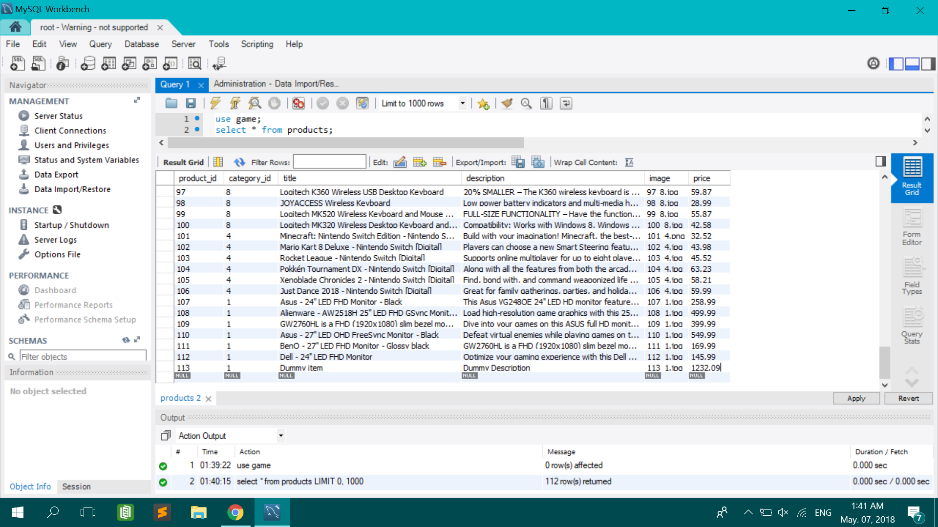

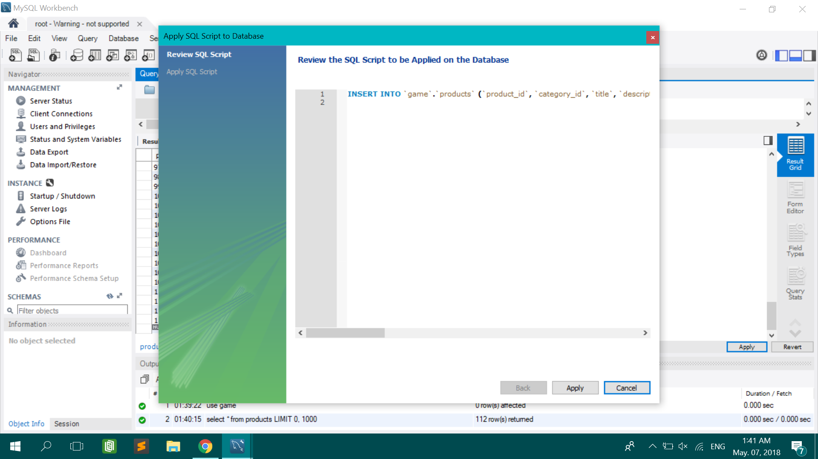

4 | Page

**Step 5:** After you’ve successfully added an item, you can now see if it actually works so go to the browser to launch your website hosted by XAMPP by typing this in the search tab: ***localhost//practicum***

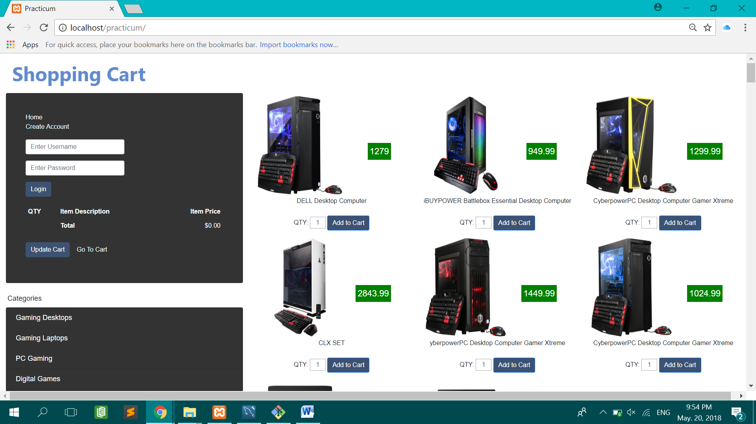

**Step 6:** You can also add some categories. Just type this command and will display all the current categories in your database.

Command: ***select * from categories;***

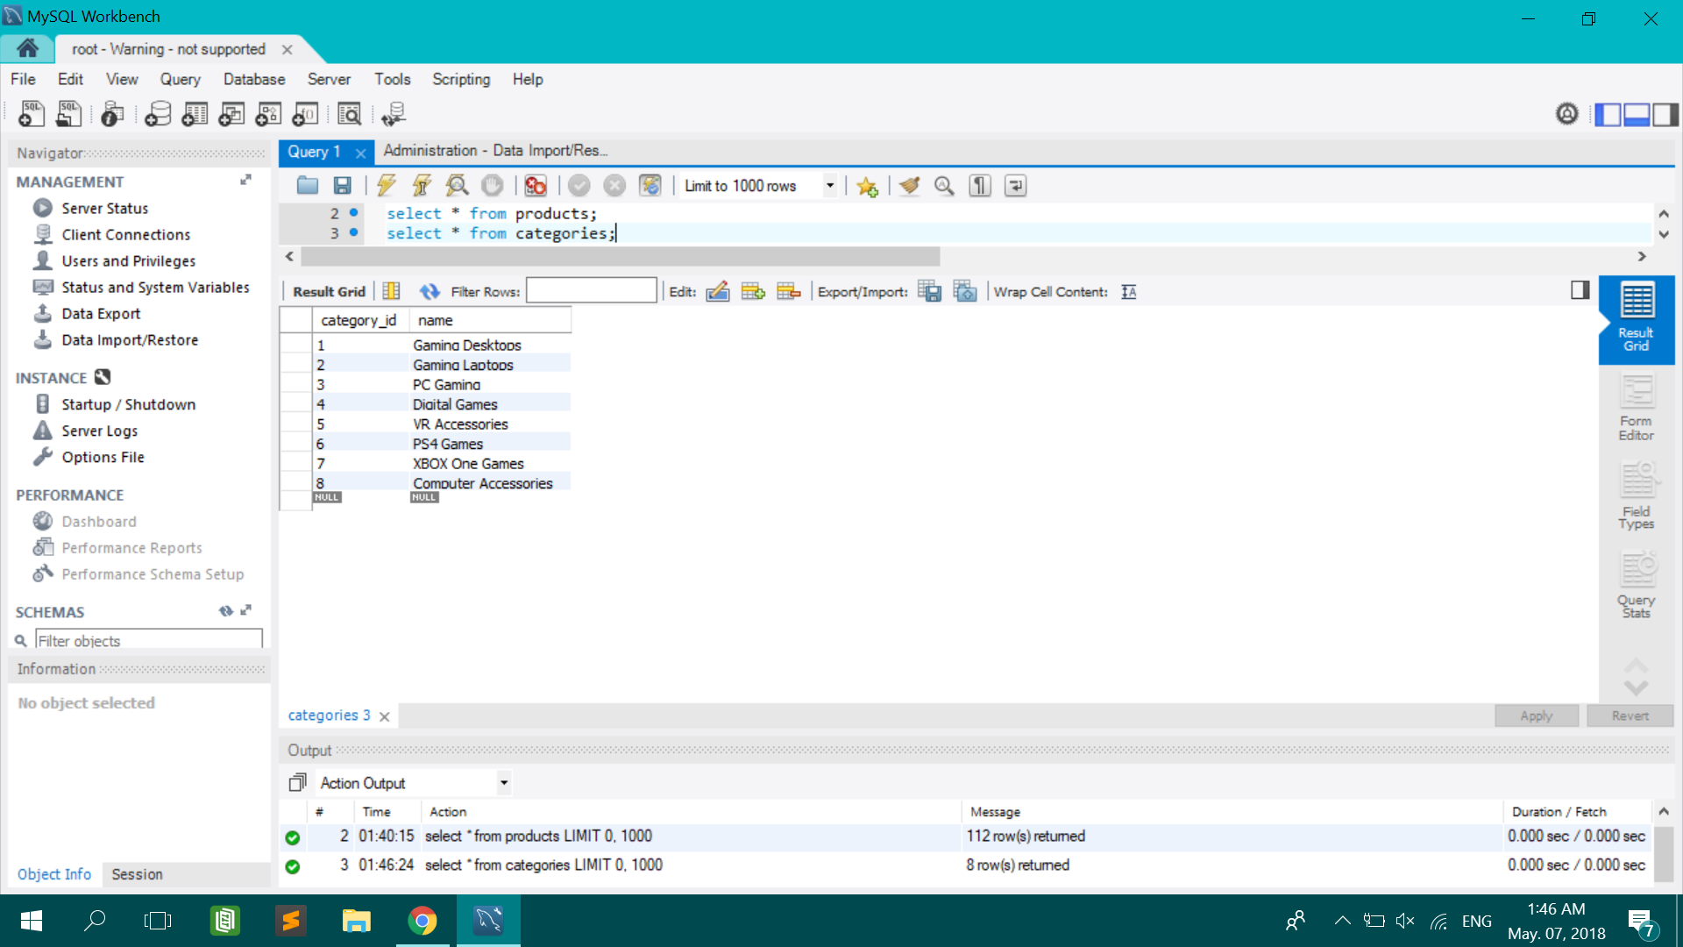

5 | Page

**Step 7:** After adding another category, you can now check it to the browser if you’ve successfully apply it.

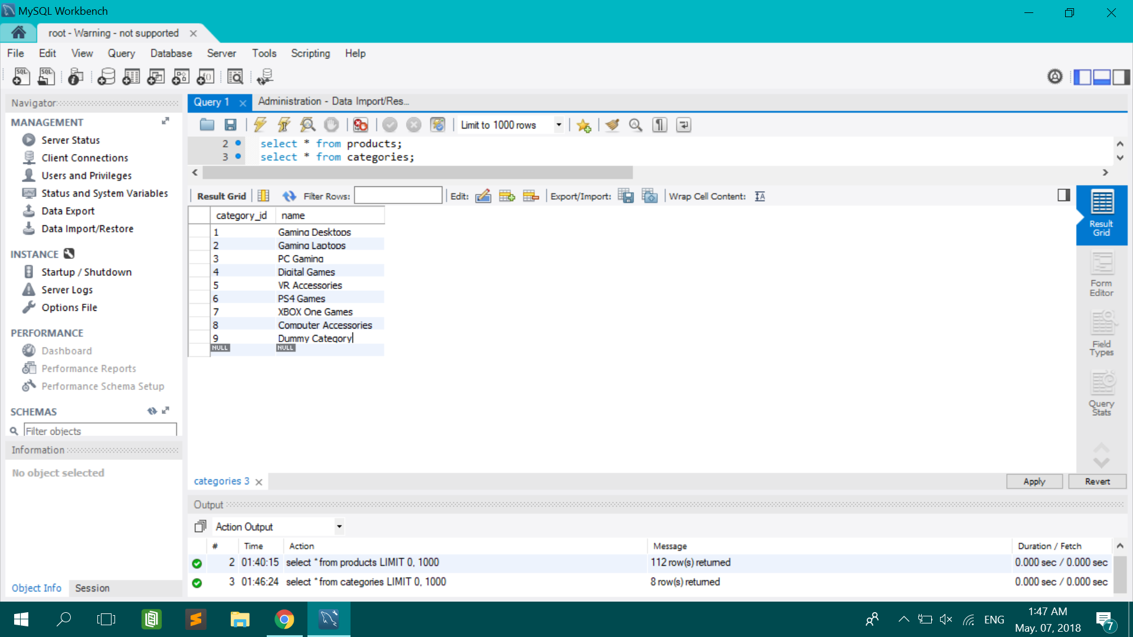

**Step 8:** After logging in into our website, it automatically cached the user that has entered into our website to buy a specific item. So you can see the all users by typing this command.

Command: ***select * from users;***

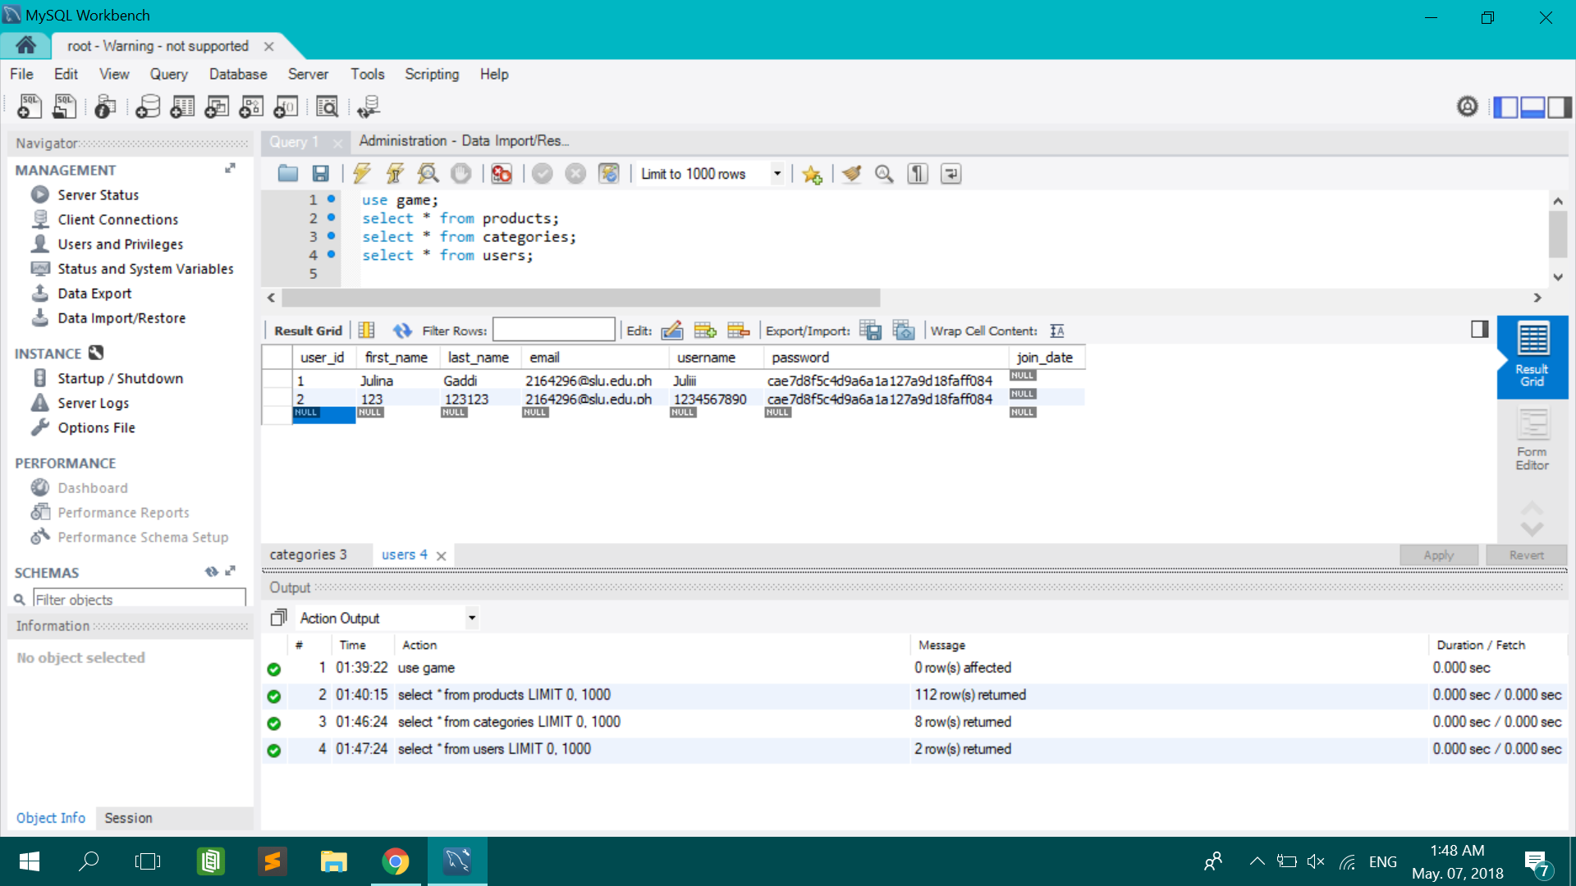

6 | Page